Short pilgrimage-walk 5 kilometers in Svanemosen near Kolding
Saturdays 11.th of May and 28.th of September 2019 from 1 pm-5 pm
We start at Simon Peter`s Church and go together by car to Svanemosen outside Kolding.
During the walk we have a text from the Bible, The Lord`s Supper, and mostly silence for contemplation.
Remember good shoes for walking and a waterbottle for drink.
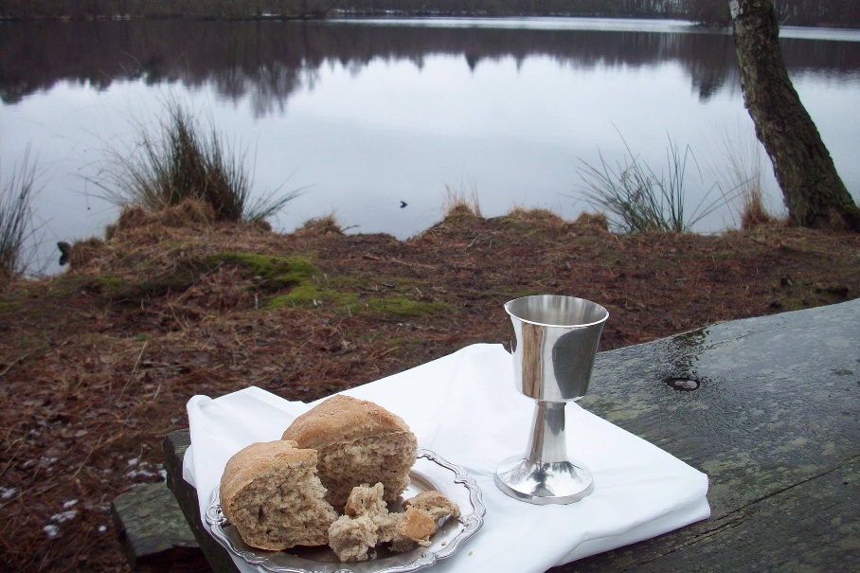
Arranged by Simon Peter`s Church, Fordybelsesudvalget
Contact:
Birgit Urd Andersen, pastor
Mail: birgiturd@birgiturd.dk. Telephone: 2894 0273
Website: birgiturd.dk
or contact :
Elizabeth Padillo-Olsen in the International Church, Kolding, for more information.

